INFLUENZA

BIOLOGY WA ATAR UNITS 3 & 4
Reading
Chapter 12 page 410 - 413
Chapter 13 page 435 – 436

Questions
Set 12.2 1 – 8
Set 13.2 1 – 5 page 435

BIOZONE
83 Viral Diseases
86 Human Viral Diseases

Topic Question | Notes
State the name of the disease and the name of the virus | INFLUENZA
Label the diagram of the enveloped virus and list the structural features of the virus | 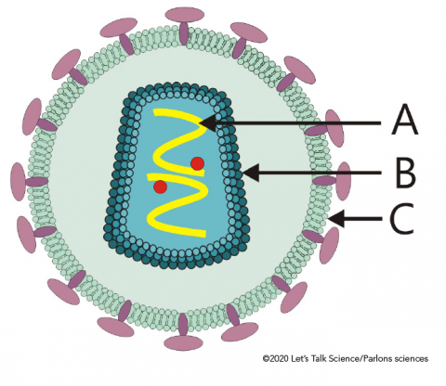
list the structural features of the virus that causes influenza

Describe the life cycle of the influenza virus

NOTE: you will describe the mode of transmission and virus replication in more detail below

- State the mode of transmission of the influenza virus  - Describe how the influenza virus is spread of one host to another  - How does this mode of transmission influence the spread of influenza | State the mode of tranmission of the influenza virus  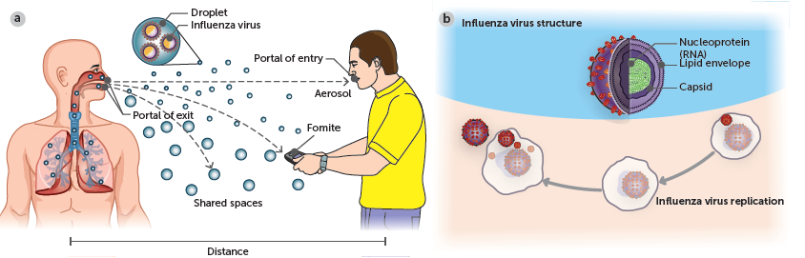  Using the diagram describe how the influenza virus is spread from an infected host to a susceptible host
Describe how the influenza virus replicates

Using your knowledge of how an enveloped virus replicates. Draw a diagram to show how the influenza virus replicates in an epithelial cells in the respiratory tract
State the Incubation period of the Influenza virus.  Describe the implications of this incubation period on the spread of the disease | Read page 413 of Biology WA ATAR UNITS 3 & 4
List the Symptoms of Infection

State the Treatments used for Influenza
Describe methods of Control for Influenza

